IN MEMORY OF BOB SHOR
1941-2017
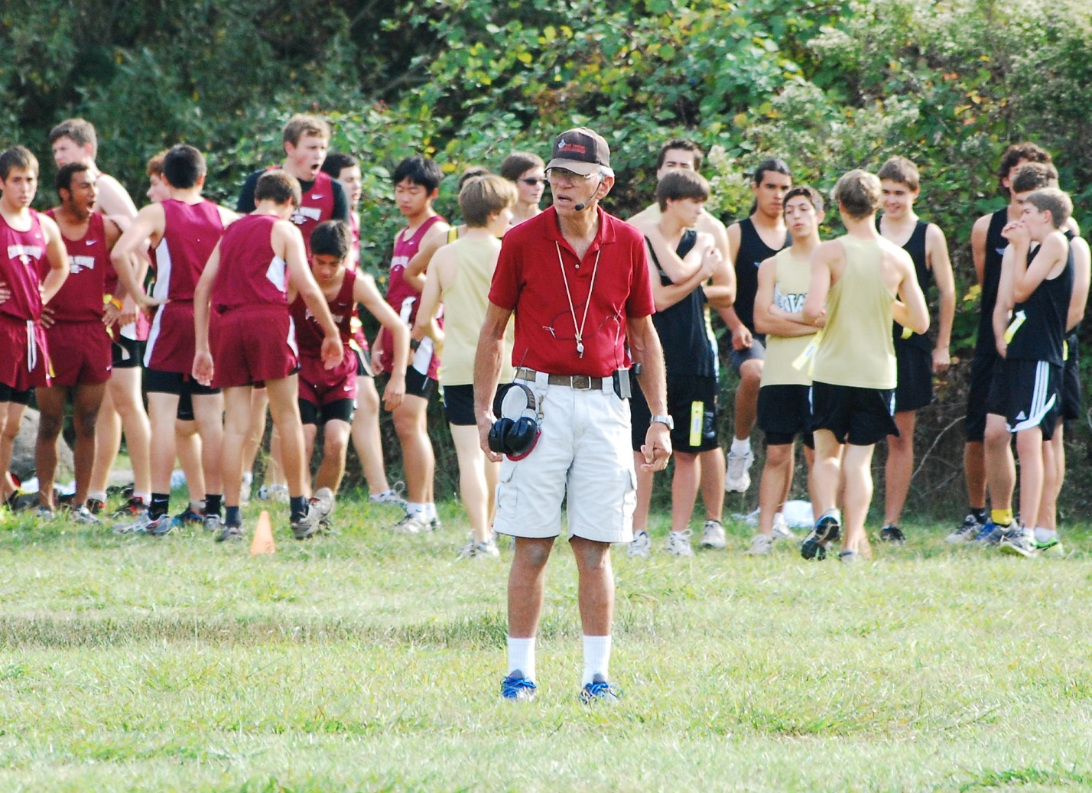

“Not just you, but everybody”
These words -- repeated 1000s of times over the course of decades -- were the signature phrase of Bob Shor, legendary track and cross country official, race starter, and coach.
Bob was many things: Brooklyn native, decorated Army Captain, Vietnam Veteran, salesman, to name a few. But at his core, in his DNA, Bob was a coach who believed the focus and discipline that running provided young athletes could be life-changing.
Bob devoted much of his life to providing these life-changing moments: as a dedicated coach of the Santa Rosa Express, a youth track and cross country club; as an expert track and cross country official who oversaw 1000s of meets in California and across the country; as a long-time coach of the Santa Rosa High School track and cross country teams; and as an influential member of the Empire Runners Club. Although his wisdom and expertise were invaluable, he shared both freely and rarely sought compensation for his time.
Bob meticulously studied the many rules and regulations that govern track and cross country meets. Always the first to arrive and the last to leave, Bob knew that the experience athletes would have on meet day depended on his preparation, organization, and knowledge. He consulted on local track designs, repaired equipment, pulled weeds, and greased hurdles. Bob would do anything to help athletes young and old improve and reach their goals.
The cross country course here at Spring Lake has been the site of many memorable and defining Bob Shor moments as an official, starter, and coach. Whether it was a simple dual meet between cross-town rivals, the Jackrabbit Derby hosted by Empire Runners, or the Viking Opener with 1000+ athletes, Bob brought the same level of dedication and expertise to every event he oversaw here in the meadow.
Gruff yet gentle, cantankerous yet caring -- Bob Shor was an icon, an institution, a legend. During his 76 years, he touched 1000s of athletes’ lives and never missed a practice or a meet even while he fought a long battle with lung cancer.
“Not just you, but everybody.” Although this phrase is merely an excerpt from longer instructions Bob would recite on the starting line before a race, these 5 words are so much more than that. They embody Bob’s generosity and remind us to think of not just ourselves, but others, as we run this race we call life.

