SPRING LAKE PARK BESTS
2.97 mile course bests, established in 1987
More info at redwoodempirerunning.com/springlake

Boys Girls
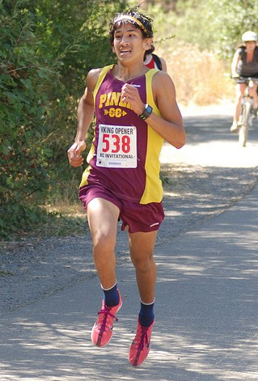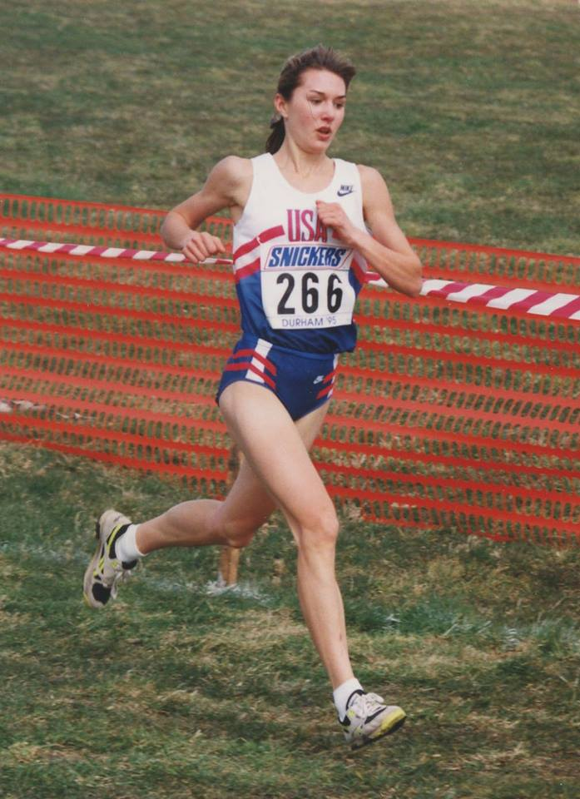
14:43 Luis Luna, Piner #1 2011 16:15 Julia Stamps, Santa Rosa #1 1995
14:50 Ryan Mack, Ukiah #1 1998 16:31 Amber Trotter, Ukiah #1 2001
15:01 Steve Laurie, Maria Carrillo #1 1998 16:43 Sara Bei, Montgomery #1 1998
15:01 Paul Holden, Ukiah #2 2012 16:51 Sarah Sumpter, Healdsburg #1 2007
15:05 Celedonio Rodriguez, Elsie Allen #1 1998 17:04 Trina Cox, Santa Rosa #2 1998
15:05 Andrew Zellman, Ukiah #3 2009 17:06 Jenny Aldridge, Maria Carrillo #1 2001
15:05 Colton Swinth, Maria Carrillo #2 2019 17:07 Jacque Taylor, Casa Grande #1 2008
15:06 Reesey Byers, Santa Rosa #1 2009 17:11 Gabrielle Peterson, Healdsburg #2 2018
15:08 Sterling Lockert, Petaluma #1 2008 17:17 Hanne Thomsen, Montgomery #2 2021
15:09 Blake McDowall, Montgomery #1 2006 17:18 Harper McClain, St. Helena #1 2019
(10) (10)
15:13 Jaime Silva, Piner #2 2011 17:24 Phyliss Blanchard, Rancho Cotate #1 2003
15:13 Ryan Anderson, Maria Carrillo #3 2012 17:24 Julie Nacouzi, Montgomery #3 2009
15:14 Ryan Douglas, Petaluma #2 2012 17:30 Nicole Lane, El Molino #1 2011
15:15 Rory McLeod, Santa Rosa #2 2008 17:30 Delaney White, Santa Rosa #3 2015
15:15 Alex Conner, Sonoma Valley #1 2011 17:36 Rylee Bowen, Sonoma Academy #1 2014
15:19 Alexi Taylor, Cardinal Newman #1 2011 17:39 Amy Robinson, Maria Carrillo #2 2002
15:20 Daniel Pride, Santa Rosa #3 2015 17:40 Sarah Bashel, Montgomery #4 1998
15:21 Zach Barrett, Santa Rosa #4 1994 17:46 Kim Conley, Montgomery #5 2003
15:21 Nicholas Rauch, Casa Grande #1 2014 17:47 Kim Handel, Montgomery #6 2002
15:21 Rory Smail, Maria Carrillo #4 2019 17:47 Shelby Leland, Ukiah #2 2002
15:21 Jacob Donohue, Maria Carrillo #5 2021 (20)
(21) 17:54 Lauren Curtin, Maria Carrillo #3 2008
15:24 Hugh Dowdy, Petaluma #3 2009 17:56 Mary Deeik, Vintage #1 2018
15:24 Matt Salazar, Casa Grande #2 2014 17:57 Adria Barich, Casa Grande #2 2015
15:24 Andre Williams, Sonoma Academy #1 2018 17:59 Isabel Andrade, Petaluma #1 2008
15:24 Pierce Kapustka, Maria Carrillo #5 2019 18:00 Lauren Kraus, Maria Carrillo #4 2011
15:26 David Toomey, Montgomery #2 1993 18:01 Ashley Moffet, Casa Grande #3 2010
15:26 Zac West, Maria Carrillo #6 2014 18:05 Kristin Sanzari, Maria Carrillo #5 2004
15:26 Brian Schulz, El Molino #1 2016 18:06 Leanne Fogg, Maria Carrillo #7 2004
15:27 Matt Fitch, Montgomery #3 2002 18:06 Celeste Berg, Montgomery #8 2008
15:27 Calvin Thigpen, Maria Carrillo #7 2006 18:06 Sydnie Rivas, Maria Carrillo #7 2017
15:27 Devin Lockert, Petaluma #4 2008 18:07 Jacqui Wentz, Maria Carrillo #8 2005
15:27 Forrest Shaffer, Petaluma #5 2010 18:09 Nika Horn, Santa Rosa #4 1990
15:27 Efren Reyes, Piner #3 2011 18:09 Jennifer Martindill, Montgomery #9 2005
18:10 Rhonda Mazza, Santa Rosa #5 1991
Italic named runners above were league champions
Class Records
Senior 14:43 Luis Luna, Piner 2011 Senior 16:19 Julia Stamps, Santa Rosa 1996
Junior 14:59 Luis Luna, Piner 2010 Junior 16:15 Julia Stamps, Santa Rosa 1995
Sophomore 15:20 Luis Luna, Piner 2009 Sophomore 16:18 Julia Stamps, Santa Rosa 1994
Freshman 15:42 Matt Salazar, Casa Grande 2012 Freshman 17:09 Sara Bei, Montgomery 1997

LEAGUE CHAMPIONSHIP MEET RECORDS
North Bay League/Oak
14:43 Luis Luna, Piner 2011 16:18 Julia Stamps, Santa Rosa 1994

North Bay League/Redwood
15:08 Sterling Lockert, Petaluma 2008 16:51 Sarah Sumpter, Healdsburg, 2007

