SPRING LAKE PARK BESTS
2.0 mile course bests, established in 1987
More info at redwoodempirerunning.com/springlake

Boys Girls
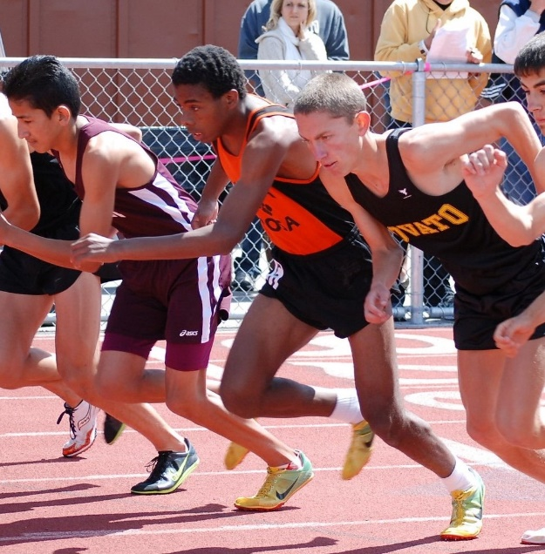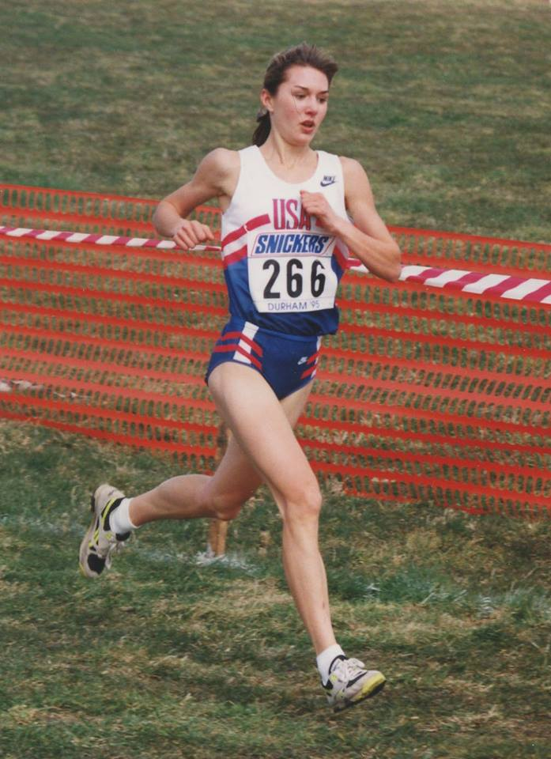
L-R Luis Luna, Reesey Byers, Erik Olson Julia Stamps
9:40 Erik Olson, Novato 2009 10:40 Julia Stamps, Santa Rosa 1996
9:44 Jude Devries, Montgomery 2022 10:42 Hanne Thomsen, Montgomery 2022
9:46 Luis Luna, Piner 2011 11:05 Sara Bei, Montgomery 1998
9:51 Luca Mazzanti, Santa Rosa 2016 11:09 Jacque Taylor, Casa Grande 2009
9:53 Dawit Tesfasilassie, Piner 2003 11:20 Amber Trotter, Ukiah 2000
9:53 Brian Schulz, El Molino 2016 11:20 Rylee Bowen, Sonoma Academy 2014
9:54 Matt Creason, Eureka 1993 11:22 Julie Nacouzi, Montgomery 2009
9:54 Ryan Mack, Ukiah 1998 11:24 Morgin Coonfield, McKinleyville 2015
9:54 Yosef Ghebray, Logan 2003 11:25 Trina Cox, Santa Rosa 1997
9:56 Daniel Pride, Santa Rosa 2015 11:25 Gabrielle Peterson, Healdsburg 2018
9:56 Russell Sullivan, Foothill 2018 (10)
(11) 11:28 Phylis Blanchard, Rancho Cotate 2003
9:57 Lucas Chung, Windsor 2018 11:30 Natalie White, Oak Ridge 2002
9:58 Reesey Byers, Santa Rosa 2009 11:32 Jenny Aldridge, Maria Carrillo 2000
9:59 Celedonio Rodriguez, Elsie Allen 1998 11:33 Michelle Gallagher, Sacred Heart Cathedral 2002
9:59 Steve Laurie, Maria Carrillo 1998 11:34 Mary Deeik, Vintage 2018
9:59 Jordan Kinley, Maria Carrillo 1999 11:38 Shannon Rowbury, Sacred Heart Cathedral 2000
9:59 Shaun Lyle, Eureka 1999 11:39 Delaney White, Santa Rosa 2015
10:00 Rory McLeod, Santa Rosa 2008 11:41 Nicole Lane, EL Molino 2011
10:00 Emmanuel Guzman, Vintage 2018 11:46 Sarah Sumpter, Healdsburg 2007
10:02 Matt Salazar, Casa Grande 2014 11:47 Shelby Leland, Ukiah 2002
(20) (20)
10:03 Brian Pruyn, Vintage 1995 11:48 Kelly Rogers, Healdsburg 2000
10:03 Paul Holden, Ukiah 2012 11:49 Nika Horn, Santa Rosa 1991
10:04 Beau Bettinger, Castro Valley 2000 11:50 Kate Bowen, Rincon Valley Middle 2015
10:05 Jaime Silva, Piner 2012 11:51 Kim Conley, Montgomery 2003
10:07 Steve Guerrini, Santa Rosa 1990 11:52 Katy Lee, Sonoma Academy 2011
10:07 Alexi Taylor, Cardinal Newman 2011 11:57 Amy Robinson, Maria Carrillo 2002
10:08 Blake McDowall, Montgomery 2006 11:58 Sarah Hallas, Ursuline/CN 1996
10:09 Nicholas Rauch, Casa Grande 2014 11:59 Pamela Richardson, Montgomery 1994
(28) 12:00 Sarah Bashel, Montgomery 1998
10:10 Juanjo Soriano, Santa Rosa 1991 12:00 Amelie Maltz, Lick Wilmerding 2022
10:10 Tomas Garcia, Watsonville 1994 (30)
10:10 Adam Grubbs, Eureka 1994 12:01 Lauren Kraus, Maria Carrillo 2010
10:10 Jim Nelson, Napa 1995 12:02 Mackenzie Mills, Vintage 2012
10:10 Efren Reyes, Piner 2012 12:02 Seelah Kittelstrom, Montgomery 2022
10:10 Zachery Esponda, Casa Grande 2016 12:03 Lauren Curtin, Maria Carrillo 2007
10:10 Robert Swoboda, Ukiah 2016 12:03 Suzi Rozga, Santa Rosa 2008
10:10 Andre Williams, Sonoma Academy 2018 12:04 Ashley Moffett, Casa Grande 2011-12
10:11 Scott Haycock, Napa 1994 12:04 Leah Haley, Montgomery 2018
10:11 Jake Schmitt, Redwood 2002 12:04 Renae Searls, Alhambra 2021
10:12 Lehrin Morey, Eureka 1999 12:05 Hayley Ballard, San Domenico 2021
10:12 Wes Methum, Rincon Valley Christian 2016 12:05 Siena Brunetti, Cardinal Newman 2022
10:13 Aria Kiani, Montgomery 2008 12:06 Sara Jakel, Sonoma Valley 1993
10:14 Mike Contos, Montgomery 1987 12:07 Celeste Berg, Montgomery 2008
10:14 Zach Price, Windsor 2013 12:07 Isabel Moon, Novato 2012
(43) 12:07 Alyssa Hammer, Rincon Valley Christian 2018
(44)
Class Records
Senior 9:40 Erik Olson, Novato 2009 Senior 10:40 Julia Stamps, Santa Rosa 1996
Junior 9:53 Dawit Tesfasilassie, Piner 2003 Junior 10:49 Julia Stamps, Santa Rosa 1995
Sophomore 9:59 Jordan Kinley, Maria Carrillo 1999 Sophomore 10:42 Hanne Thomsen, Montgomery 2022
Freshman 10:24 Jordan Kinley, Maria Carrillo 1998 Freshman 11:07 Julia Stamps, Rincon.Vly. J.H. 1993
Alumni 9:43 Dan Aldridge, Petaluma 1993 Alumni 11:19 Shannon Sweeney, La Sierra 1992

